Hostel 1:

Title: Saint Erasmus Lodge

textDesc:

Address: 5 Edwards Lane, Tekapo.

Gps: -44.009783422904, 170.47394894695628

costNight: $30/night

numPeople: 1

numRooms: 1 bedroom, shared facilities.

Pic1: 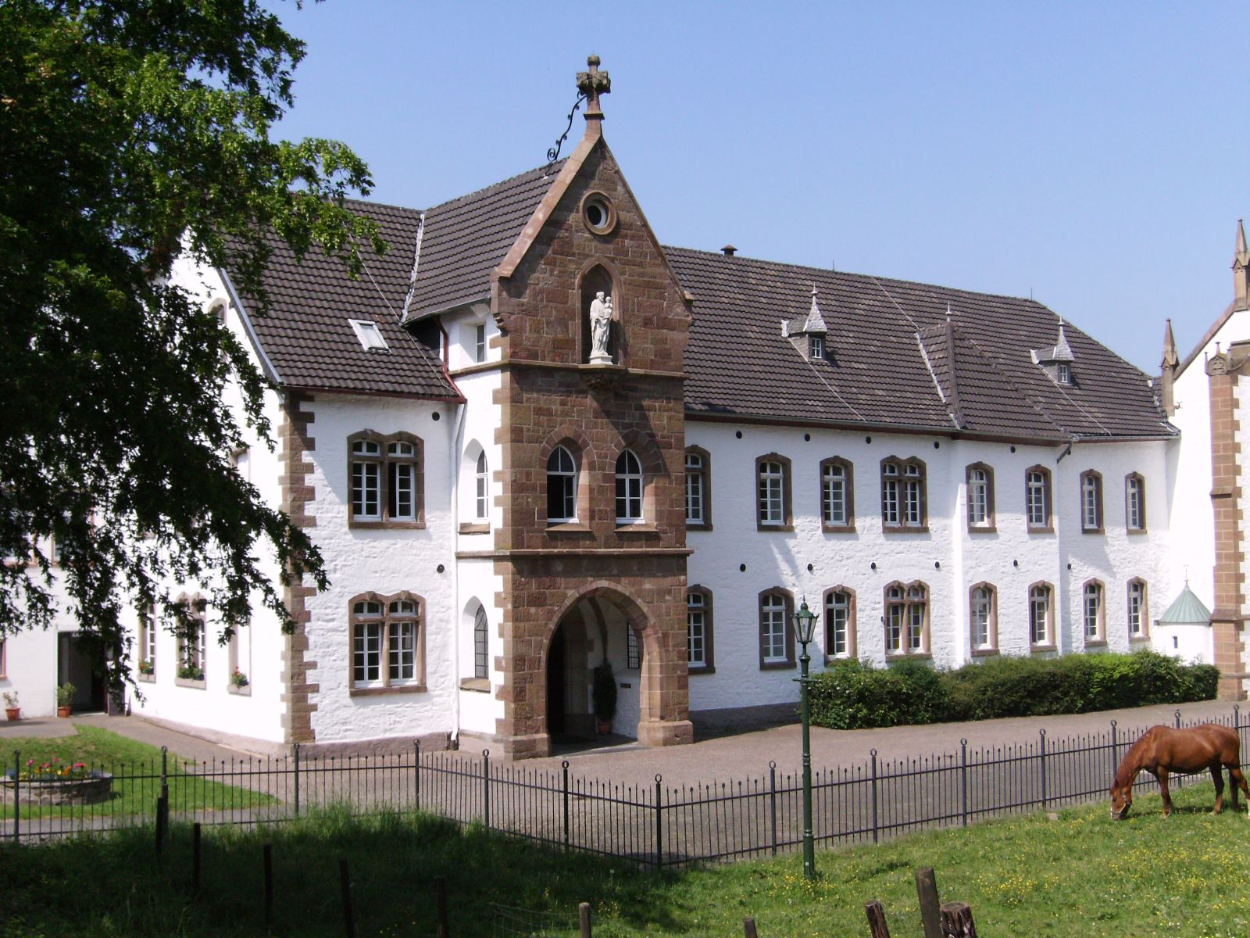

(https://commons.wikimedia.org/wiki/File:Mariawald-abbey_hostel-outside_2007-05-21_dti.jpg)

Pic2:

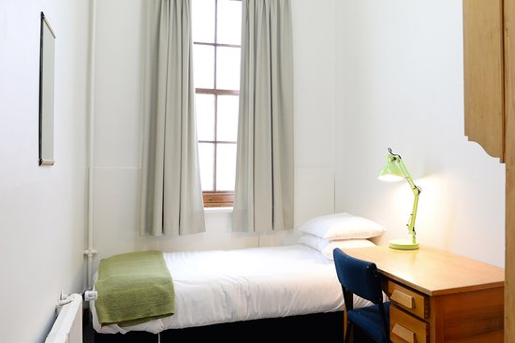

(https://www.tripadvisor.com/LocationPhotoDirectLink-g1627589-d10198369-i210724193-Burns_Lodge_at_Holy_Cross_Centre-Mosgiel_Dunedin_Otago_Region_South_Is.html)

Pic3:

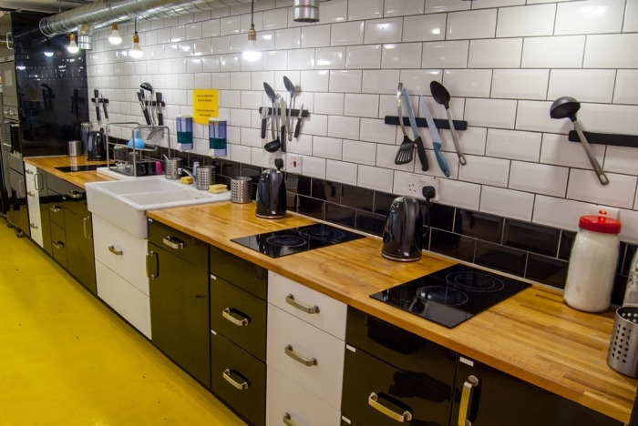

(https://hostelmanagement.com/forums/essentials-setting-hostel-kitchen.html)

Hostel 2:

Title: Aotearoa Trekkers Accommodation

textDesc:

Adress: 102 Lakeside Drive, Tekapo Springs, Tekapo.

Gps: -43.995188087830364, 170.46180045429935

costNight: $30/night

numPeople: 1

numRooms: 1 bedroom, shared facilities.

Pic1:

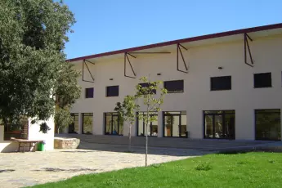

(https://www.hihostels.com/destinations/es-tremp/hostels)

Pic2:

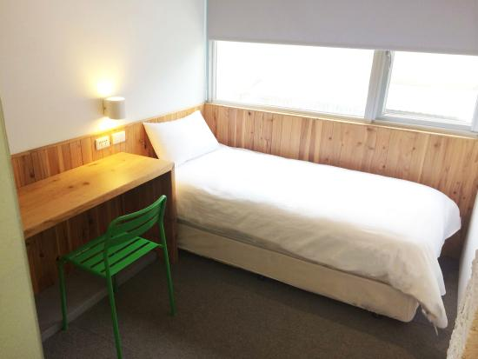

(https://www.tripadvisor.co.nz/LocationPhotoDirectLink-g13806451-d6925013-i151034404-Star_Hostel_Taipei_Main_Station-Datong_Taipei.html)

Pic3:

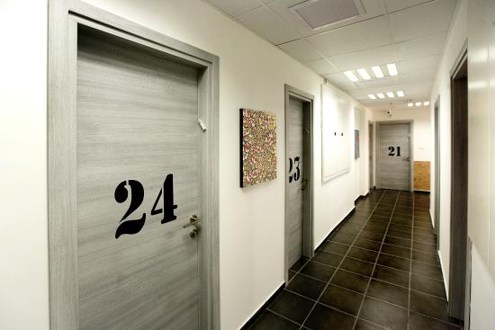

(https://en.tripadvisor.com.hk/LocationPhotoDirectLink-g293984-d7703390-i129402166-Little_Tel_Aviv_Hostel-Tel_Aviv_Tel_Aviv_District.html)

Hostel 3:

Title: Lazy Sunday Hostel

textDesc:

Adress: 376D Three Springs Road, Kimbell.

Gps: -44.062473877243875, 170.77247848927692

costNight: $30/night

numPeople: 1

numRooms: 1 bedroom, ensuite bathroom, shared kitchen.

Pic1:

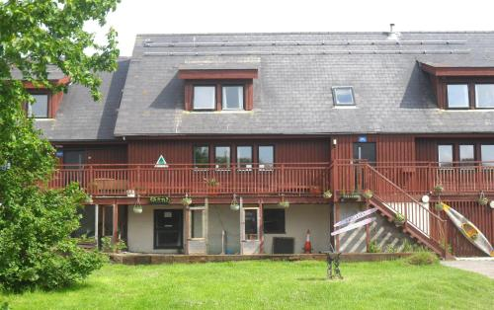

(https://www.booking.com/hotel/gb/anglesey-outdoors.html?auth_success=1)

Pic2:

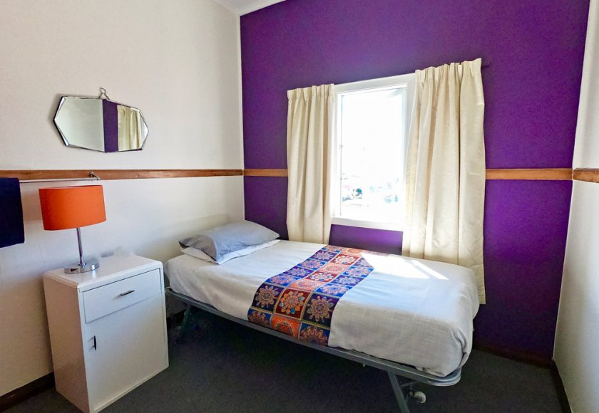

(https://www.ducksanddrakes.co.nz/backpackers-rooms/)

Pic3: 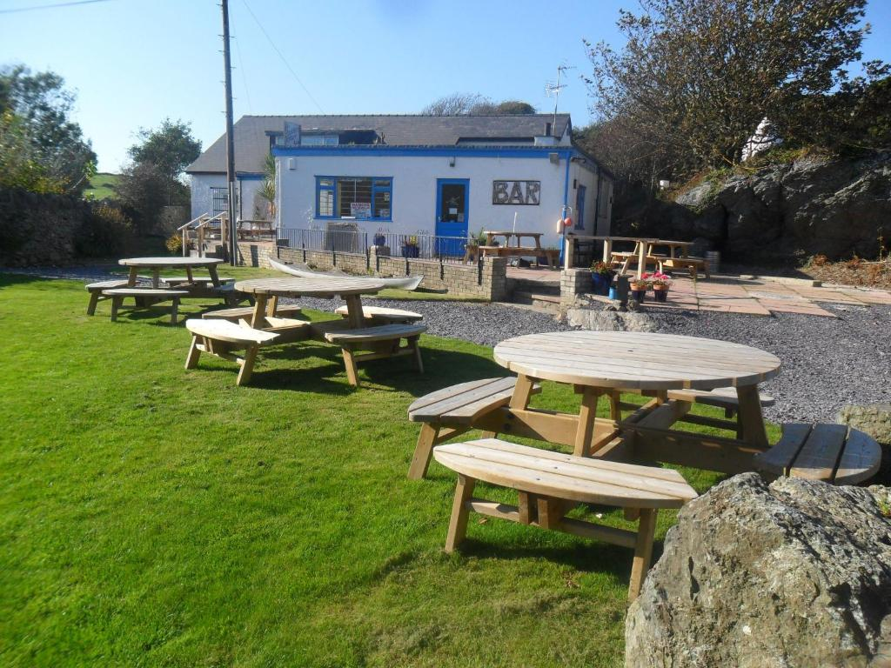

(https://www.booking.com/hotel/gb/anglesey-outdoors.html?auth_success=1&activeTab=photosGallery)

Motel 1:

Title: Chevron Motor Lodge

textDesc:

Adress: 20 Erebus Place, Tekapo.

Gps: -44.00593676623568, 170.47036076708488

costNight: 90

numNights: 3-10

numPeople: 2-4

numRooms: 1 bedroom , shared facilities, pool access.

Pic1: 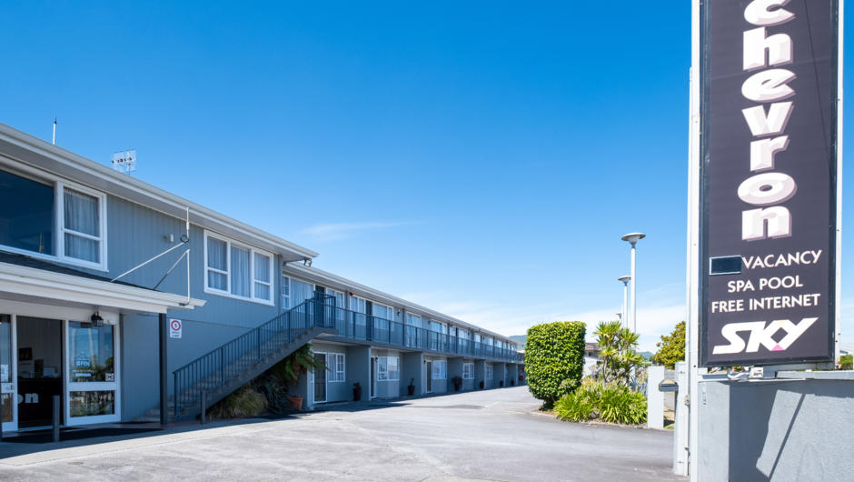

(https://www.newzealand.com/in/plan/business/chevron-motel-ltd/)

Pic2:

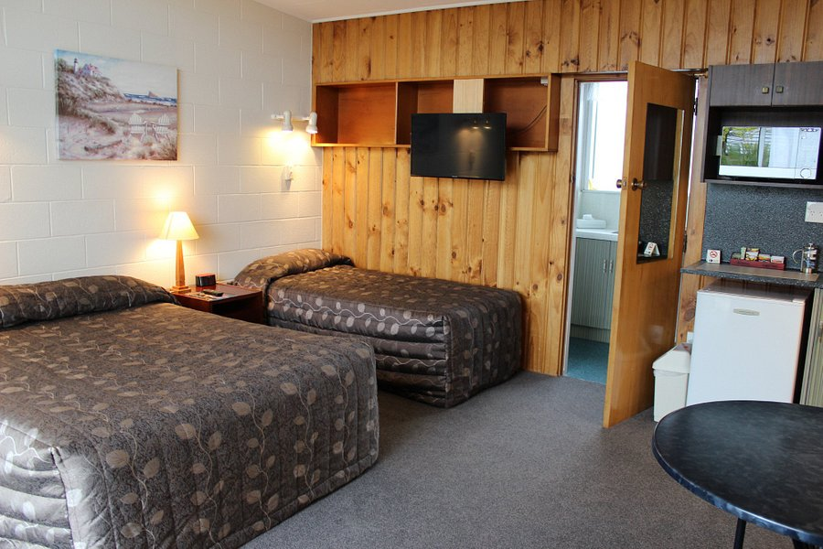

(https://www.tripadvisor.co.nz/Hotel_Feature-g255120-d1156937-zft1-Asure_Evergreen_Motel.html)

Pic3:

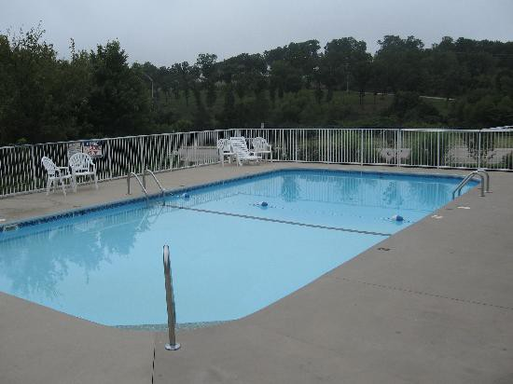

(https://medium.com/the-quintessential-q/motel-pools-deliberately-built-to-look-sad-as-fuck-75f819837c61)

Motel 2:

Title:Galaxy Stays

textDesc:

Adress: 37 Main Street, Fairlie.

Gps: -44.10142036843941, 170.82929085888716

costNight: 90

numNights: 3-10

numPeople: 2-4

numRooms: 1 bedroom, ensuite bathroom, attached mini kitchen.

Pic1: 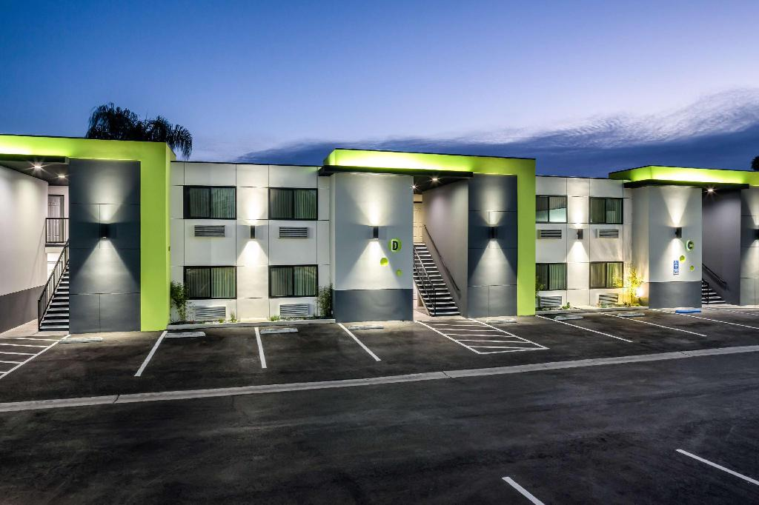

(https://www.agoda.com/motel-6-canoga-park/hotel/los-angeles-ca-us.html?cid=1844104)

Pic2:

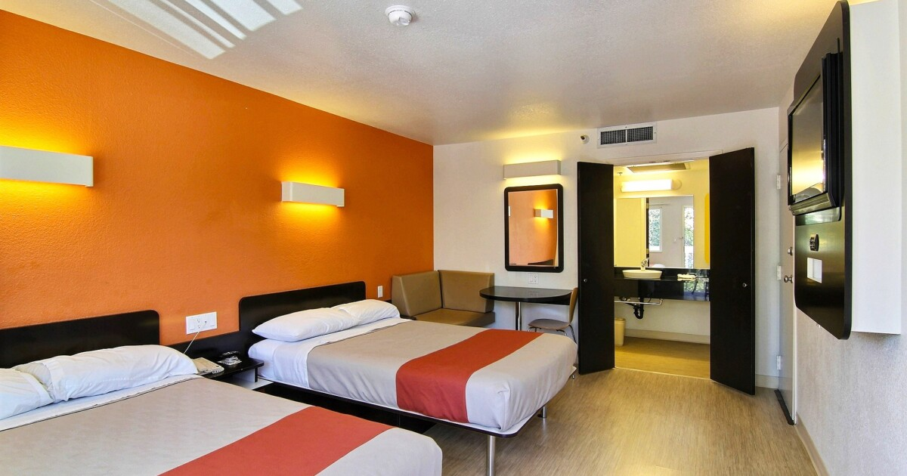

(https://www.latimes.com/travel/california/la-trb-motel-6-makeover-20160324-story.html)

Pic3:

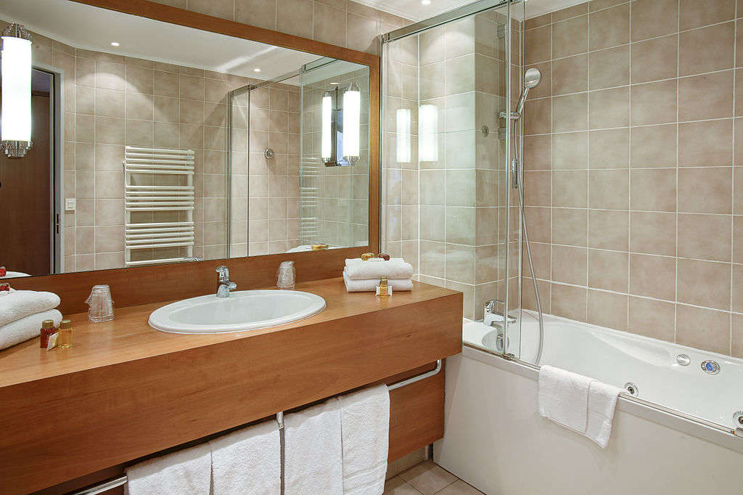

(https://www.hospitalitynet.org/opinion/4092436.html)

Motel 3:

Title: Model 4 Motel, Tekapo

textDesc:

Adress: 35 Darchiac Drive, Tekapo.

Gps:-44.00556666040913, 170.47205952578238

costNight: 90

numNights: 3-10

numPeople: 2-4

numRooms: 1 bedroom, ensuite bathroom, shared kitchen.

Pic1:

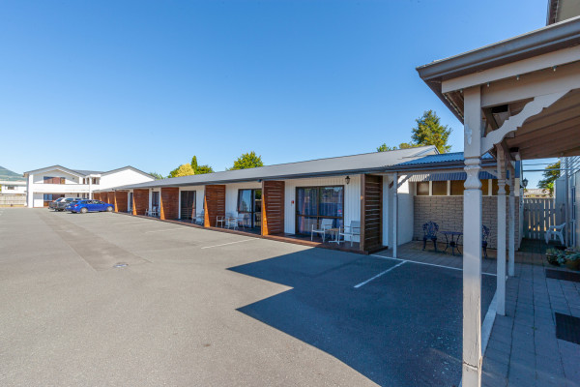

(https://www.ashbrookmotel.co.nz/accommodation/)

Pic2: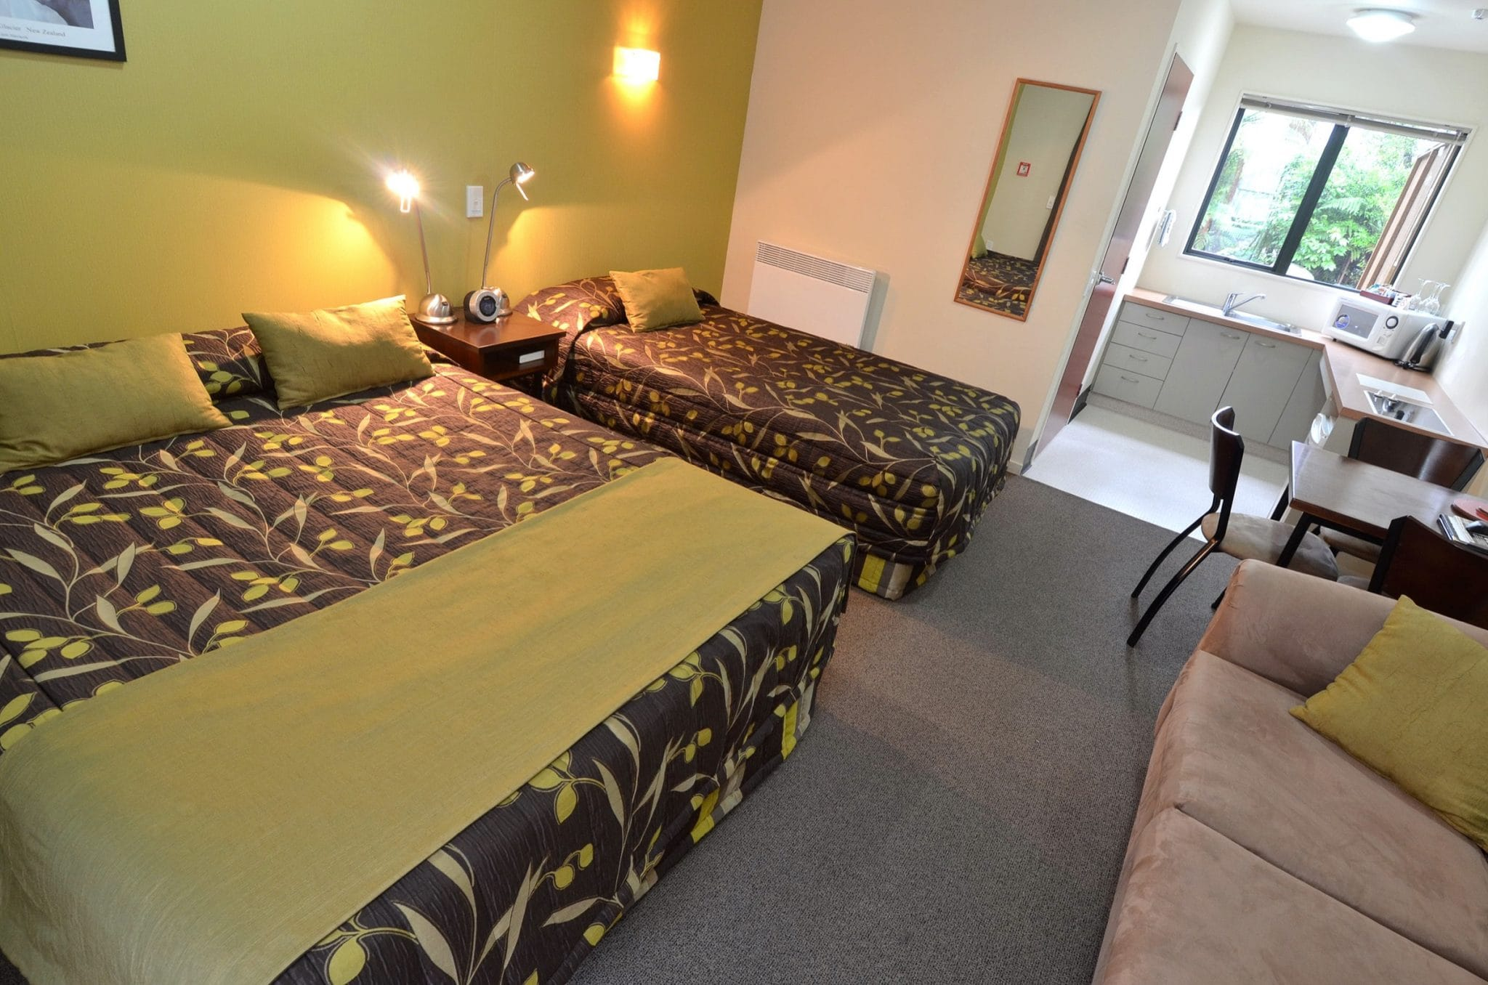

(https://rainforest.nz/room/park-motel/)

Pic3:

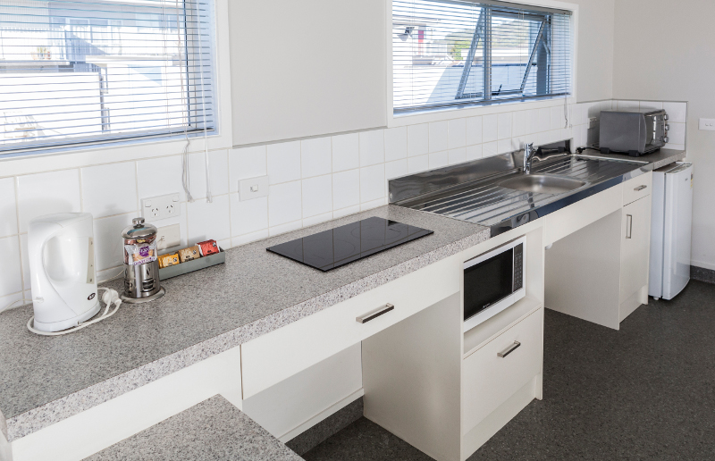

(https://www.continentalmotel.co.nz/continental-motel-whangarei-home/motel-kitchen-accessible/)

Hotel 1:

Title: Mountain View Hotel

textDesc:

Adress: 201 Godfrey Peaks Road, Tekapo Springs, Tekapo.

Gps: -43.94607574482515, 170.48139229346893

costNight: $157/night

numPeople: 1-2

numNights: 1-5

numRooms: 1 bedroom with attached living room and balcony, ensuite bathroom and spa pool access.

Pic1:

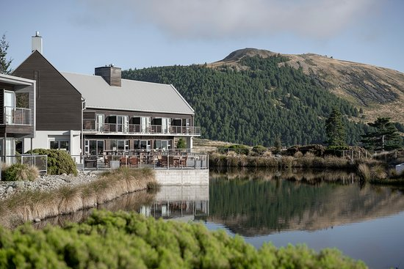

(https://www.tripadvisor.co.nz/Hotels-g644415-Lake_Tekapo_Mackenzie_District_Canterbury_Region_South_Island-Hotels.html)

Pic2: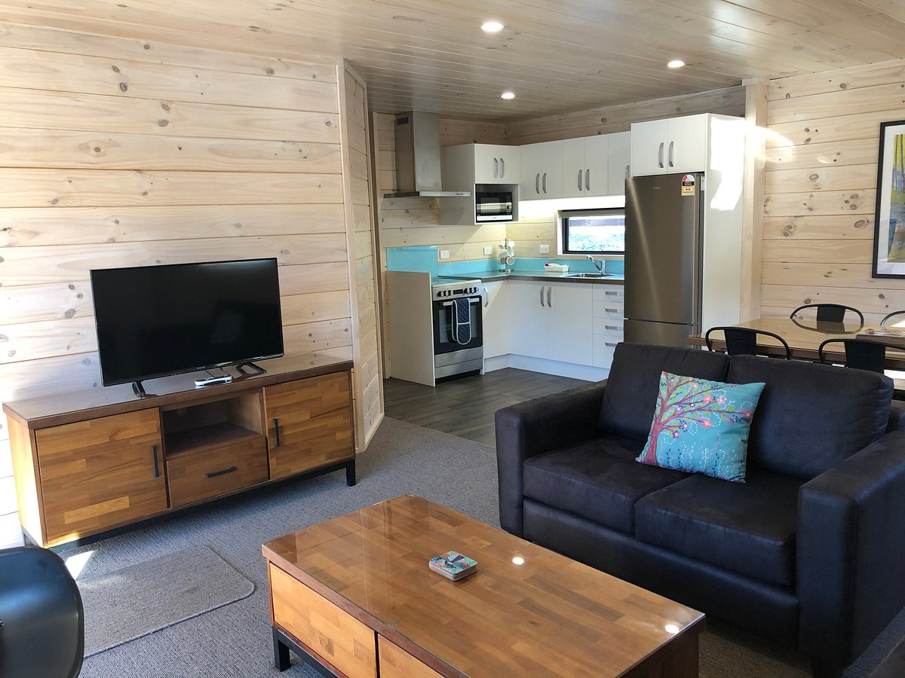

(https://www.tripadvisor.co.nz/Hotel_Review-g644415-d1034340-Reviews-Lake_Tekapo_Motels_Holiday_Park-Lake_Tekapo_Mackenzie_District_Canterbury_Region_South.html#/media/1034340/459548246:p/?albumid=101&type=0&category=101)

Pic3: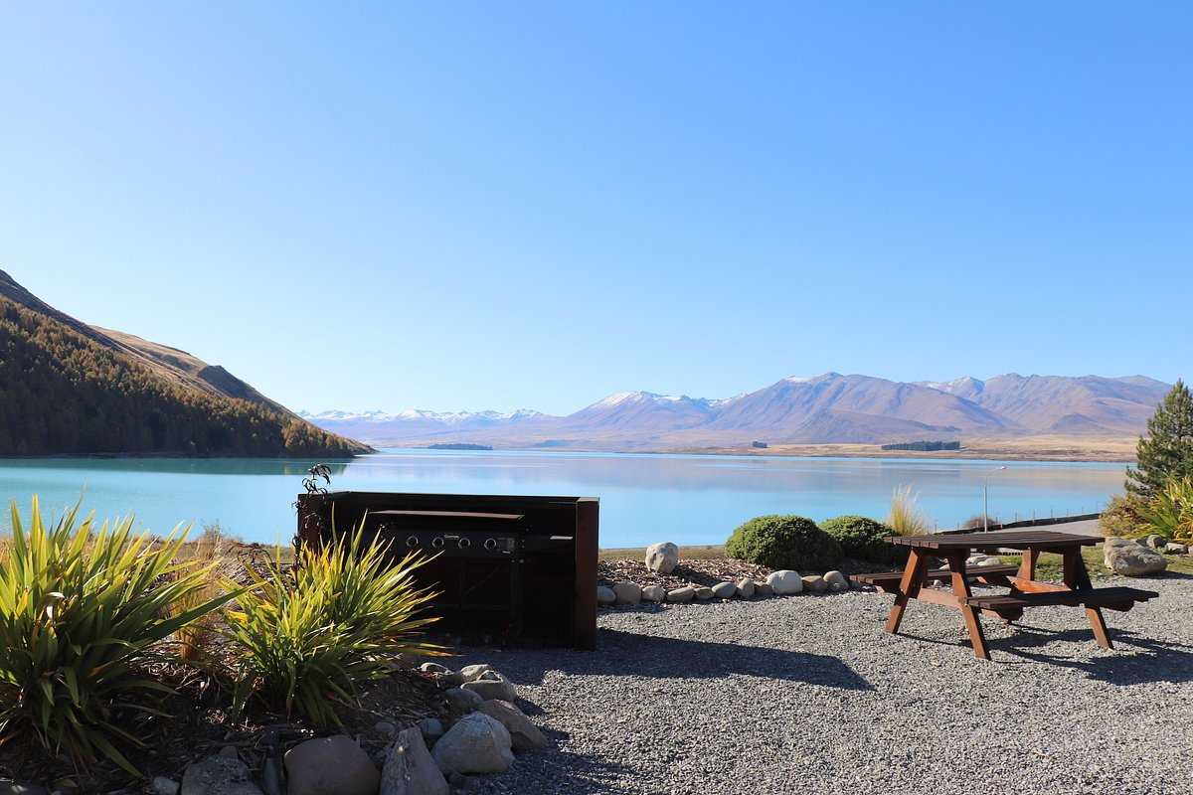

(https://www.tripadvisor.co.nz/Hotel_Review-g644415-d1034340-Reviews-Lake_Tekapo_Motels_Holiday_Park-Lake_Tekapo_Mackenzie_District_Canterbury_Region_South.html#/media/1034340/459548173:p/?albumid=101&type=0&category=101)

Hotel 2:

Title: Fairlie Hotel

textDesc:

Adress: 312 Talbot Road, Fairlie.

Gps: -44.10779553923274, 170.85153713745999

costNight: $157/night

numPeople: 1-2

numNights: 1-5

numRooms: 1 bedroom, ensuite bathroom and study, shared kitchen facilities.

Pic1: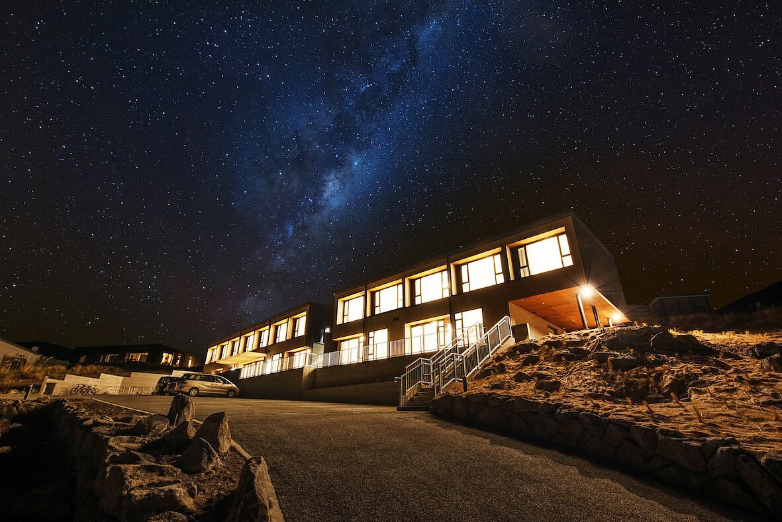

(https://www.tripadvisor.co.nz/Hotel_Review-g644415-d23346593-Reviews-Galaxy_Boutique_Hotel-Lake_Tekapo_Mackenzie_District_Canterbury_Region_South_Island.html#/media/23346593/488412716:p/?albumid=101&type=0&category=101)

Pic2: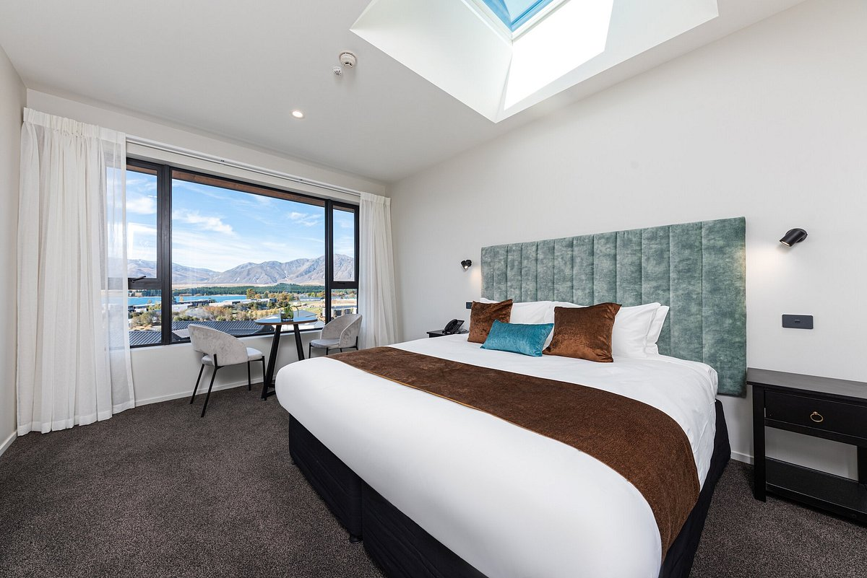

(https://www.tripadvisor.co.nz/Hotel_Review-g644415-d23346593-Reviews-Galaxy_Boutique_Hotel-Lake_Tekapo_Mackenzie_District_Canterbury_Region_South_Island.html#/media/23346593/488413575:p/?albumid=101&type=0&category=101)

Pic3: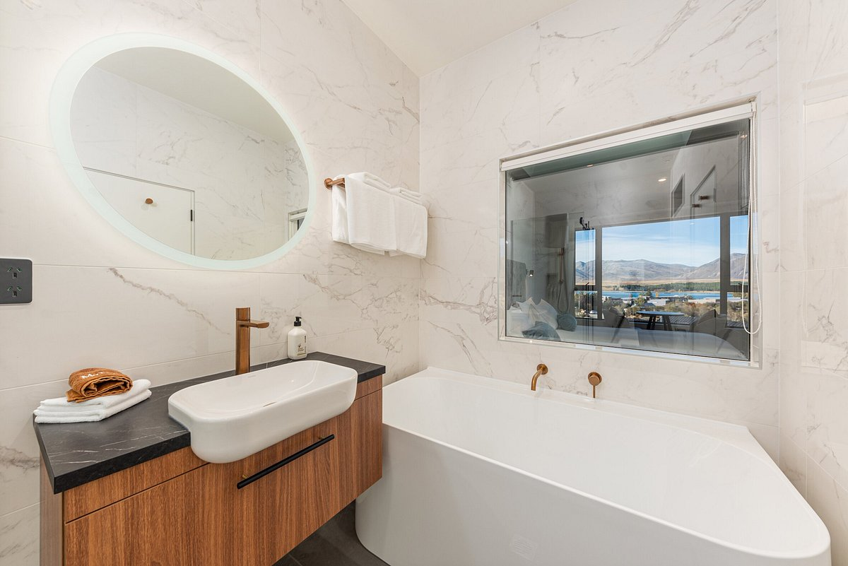

(https://www.tripadvisor.co.nz/Hotel_Review-g644415-d23346593-Reviews-Galaxy_Boutique_Hotel-Lake_Tekapo_Mackenzie_District_Canterbury_Region_South_Island.html#/media/23346593/488413564:p/?albumid=101&type=0&category=101)

Hotel 3:

Title: 4 Star Southern Castle

textDesc:

Adress:42 Hayman Road, Lake Pukaki.

Gps: -44.15788528499936, 170.22172057762708

costNight: $157/night

numPeople: 1-2

numNights: 1-5

numRooms: 1 bedroom, ensuite bathroom and kitchen, pool access.

Pic1: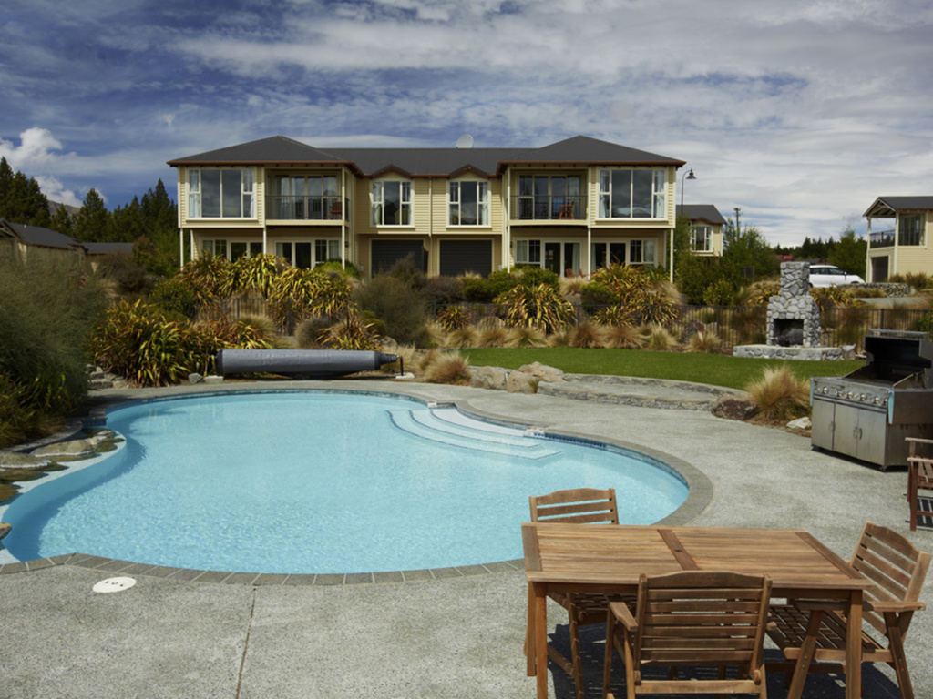

(https://all.accor.com/hotel/B3M7/index.en.shtml)

Pic2

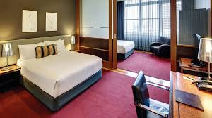:

(https://www.nytimes.com/2019/03/20/travel/shop-hotel-rooms-boutiques-retail.html)

Pic3:

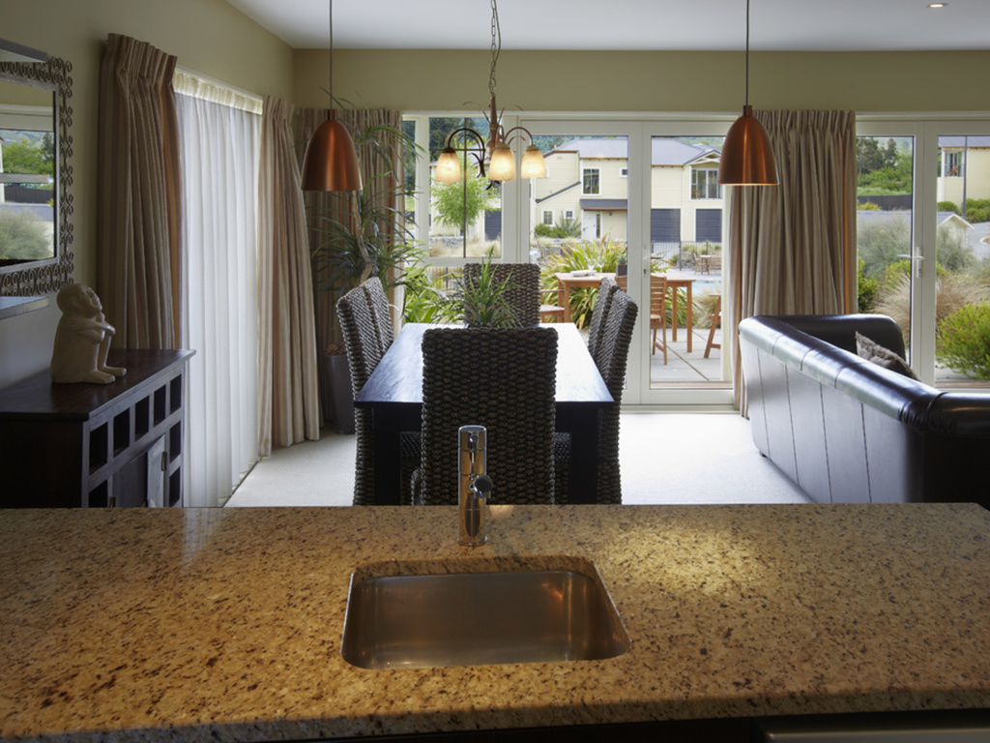

(https://all.accor.com/hotel/B3M7/index.en.shtml)

House 1:

Title: Juno’s Property

textDesc:

Adress: 5 McKenzie Pass Road

Gps: -44.194758318184086, 170.5104764713155

costNight:240/night

numPeople: 1-4

numNights: 2-15

numRooms: 1 Bedroom, 1 bathroom, open plan kitchen, living room and dining room. Outdoor hot bath.

Pic1: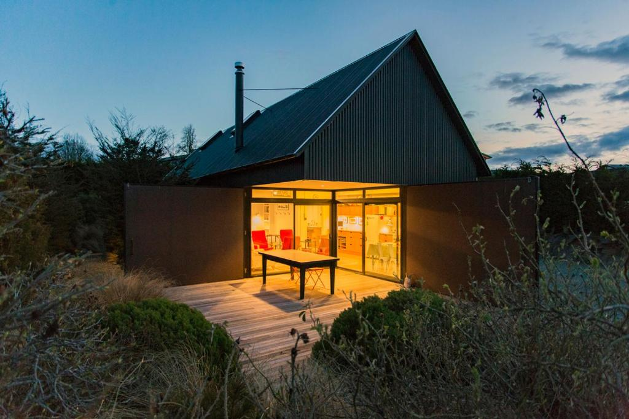

(https://www.booking.com/hotel/nz/the-black-house.html?auth_success=1)

Pic2:

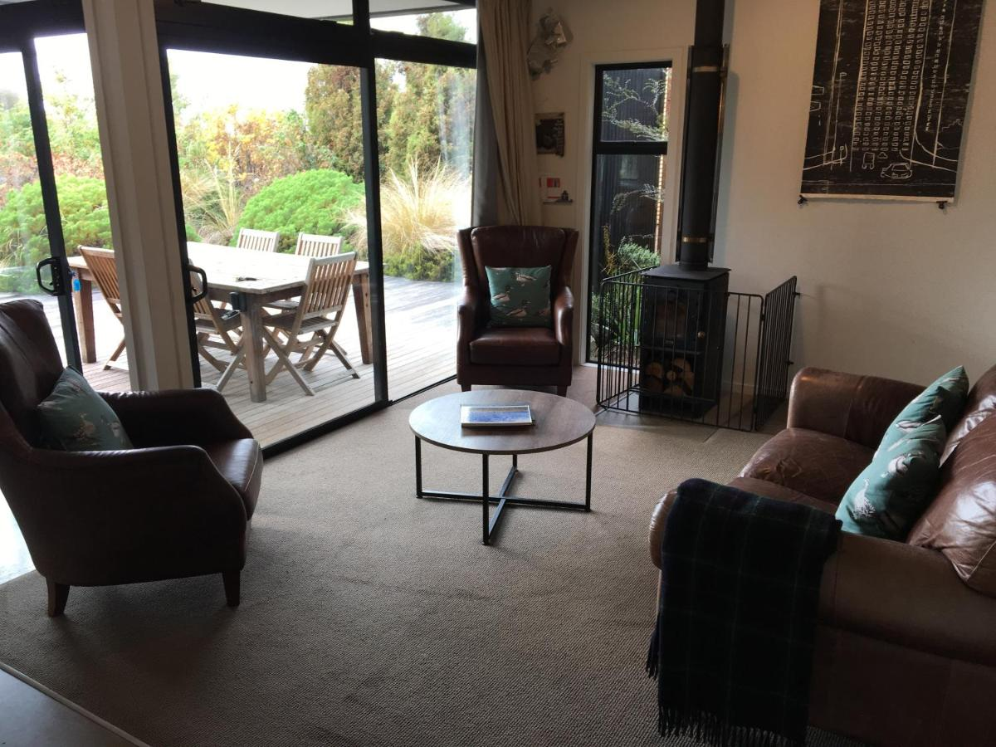

(https://www.booking.com/hotel/nz/the-black-house.html?auth_success=1&activeTab=photosGallery)

Pic3: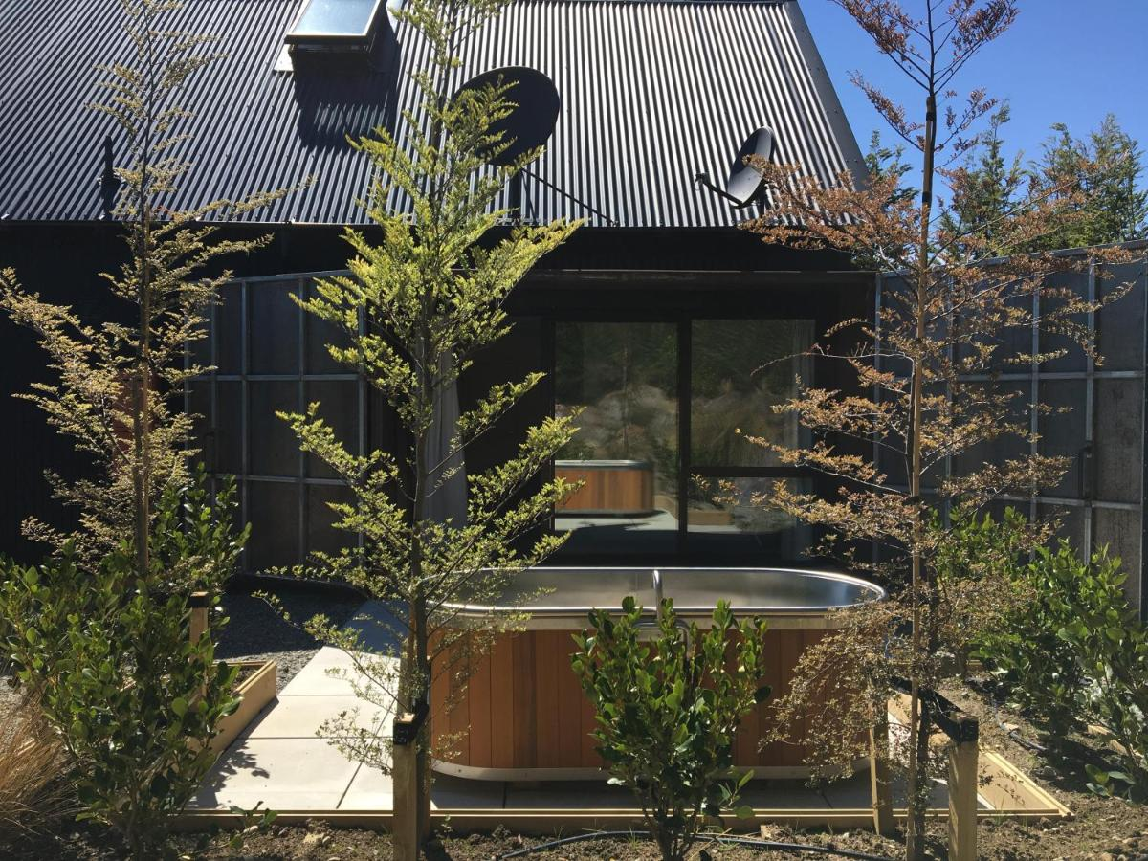

(https://www.booking.com/hotel/nz/the-black-house.html?auth_success=1&activeTab=photosGallery)

House 2:

Title: Tekapo Opera House

textDesc:

Adress: 12 Rankin Rise, Tekapo

Gps: -44.01042494873107, 170.49275243414104

costNight:

numPeople:

numRooms: 2 bedrooms, 2 ensuite bathrooms, 1 living room, 1 combined dining room and kitchen, 2 studies.

Pic1:

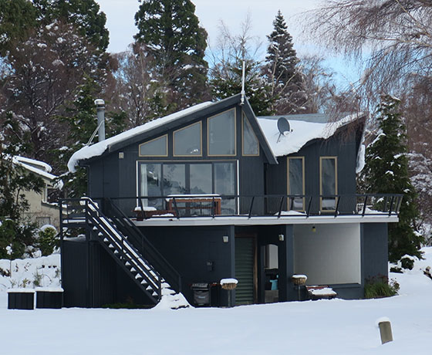

https://mackenzienz.com/galleries/lake-tekapo-holiday-homes/lake-tekapo-holiday-homes-operahouse/

Pic2:

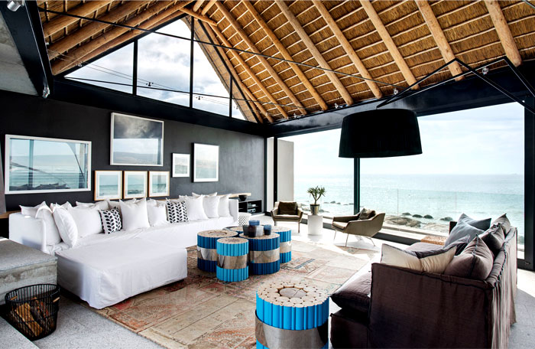

https://www.interiorzine.com/2014/12/10/silver-bay-holiday-house-by-saota-architects/

Pic3:

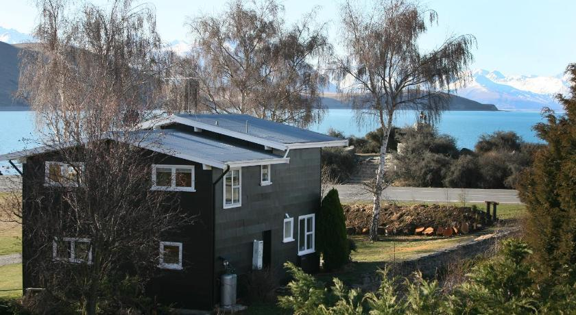

https://www.agoda.com/lake-tekapo-holiday-homes/hotel/lake-tekapo-nz.html?cid=1844104

House 3:

Title: Tripod House

textDesc:

Adress: 31 Perambulator Lane, Kimbell

Gps: -44.04548055252425, 170.75571073506416

costNight:

numPeople:

numRooms: 1 master bedroom, 2 child bedrooms, 1 open plan living room and dining room, 1 kitchen, 1 bathroom. Pool on property

Pic1:

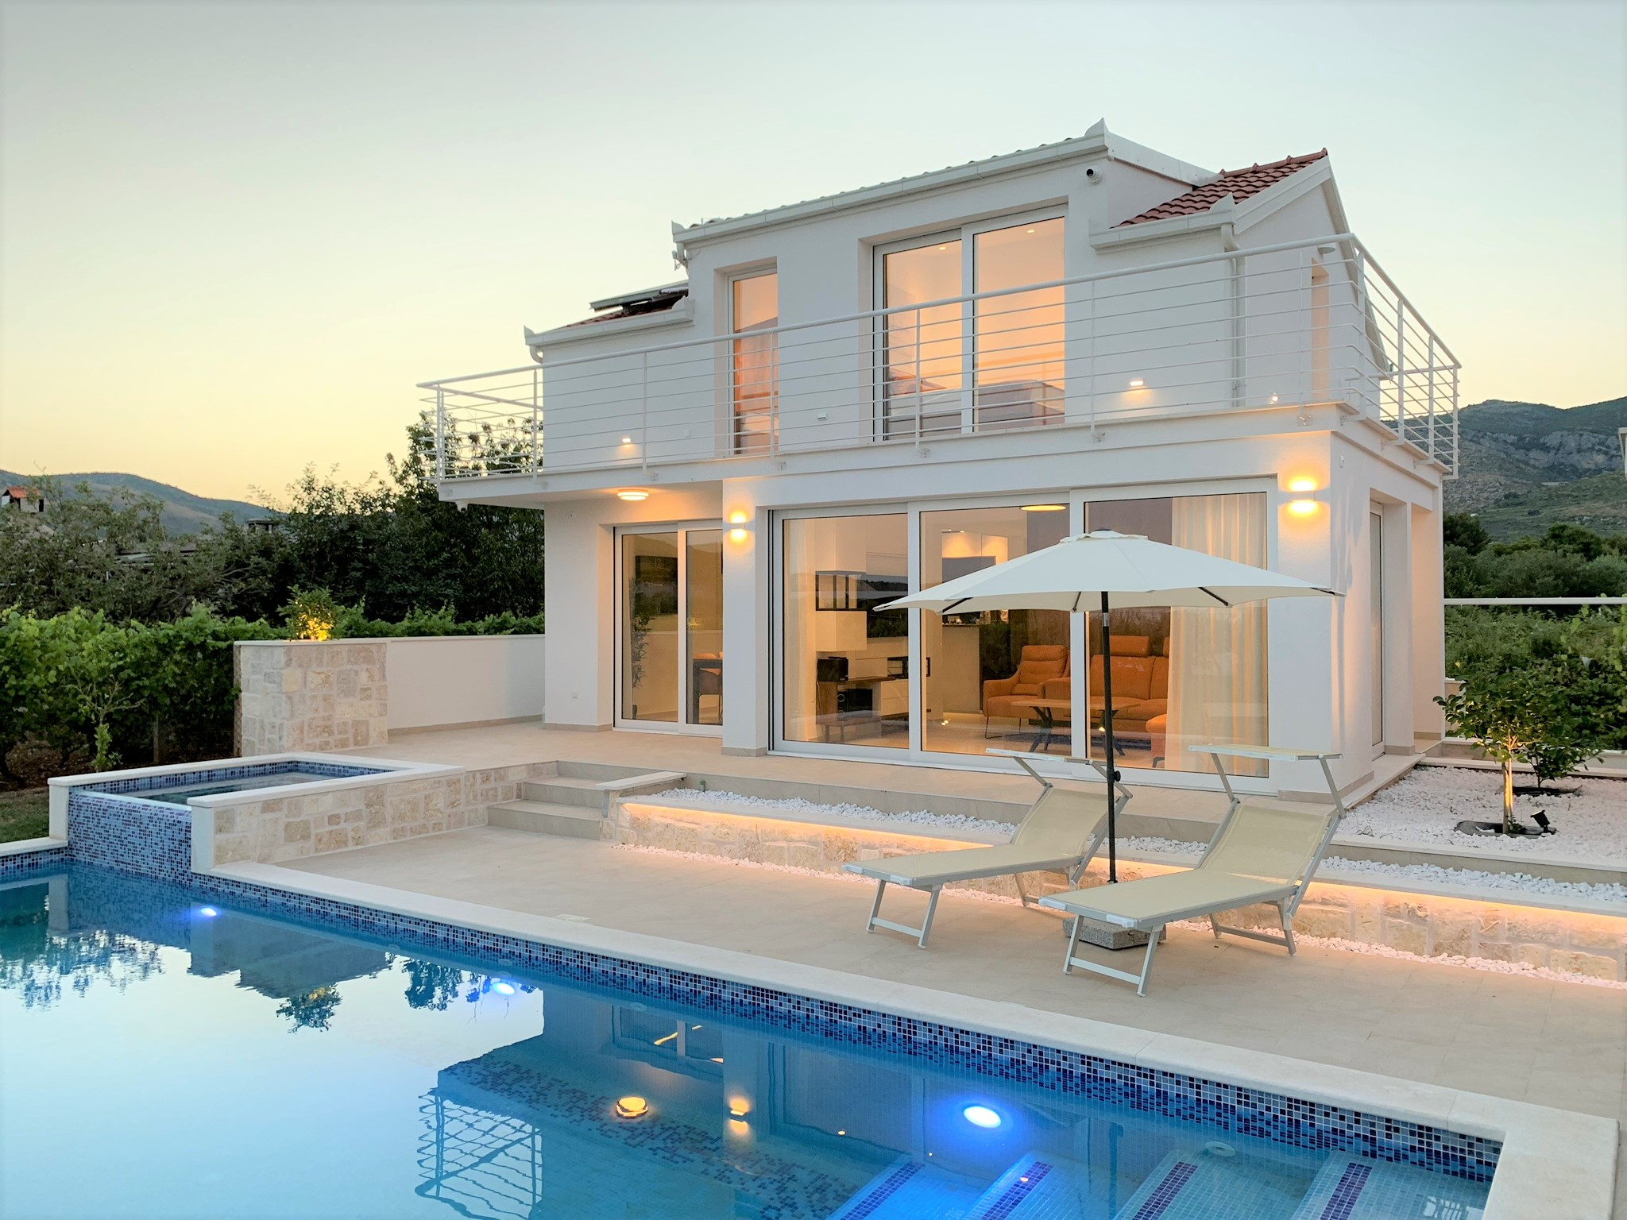

https://www.airbnb.co.nz/rooms/36285379?_set_bev_on_new_domain=1637286091_MTE5YjRkNDI5Mjlj&source_impression_id=p3_1637286096_JFE1aj8LKubLJN7i&guests=1&adults=1

Pic2:

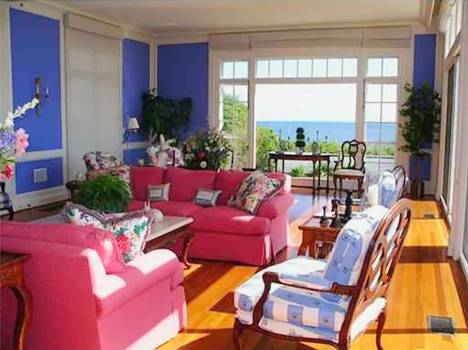

https://scenetherapy.com/taylor-swifts-rhode-island-holiday-house/

Pic3:

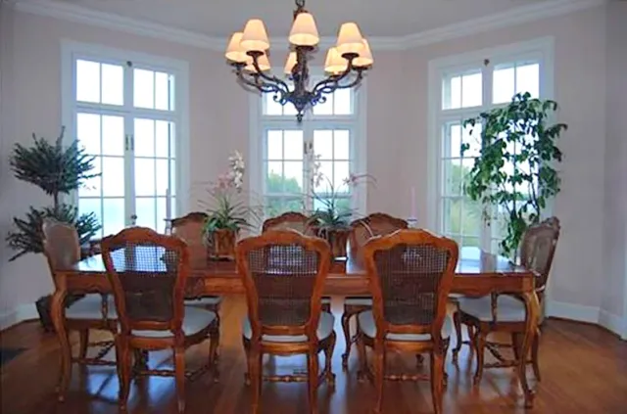

https://scenetherapy.com/taylor-swifts-rhode-island-holiday-house/

Icon references:

Shooting star:

<div>Icons made by <a href="https://www.freepik.com" title="Freepik">Freepik</a> from <a href="https://www.flaticon.com/" title="Flaticon">[www.flaticon.com](http://www.flaticon.com)</a></div>

**Menus**

Hostel:

Menu1: Weetbix, milk and tinned fruit or toast

Menu2: Assorted sandwiches or soup of the day

Menu3: Barbeque or shepherds pie (weather dependent)

Pic4:

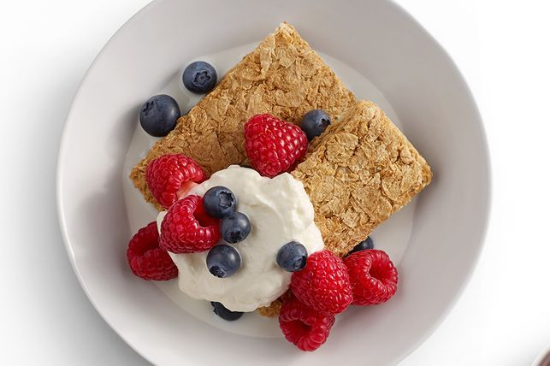

https://www.kidspot.com.au/kitchen/recipes/weet-bix-berries-yoghurt-recipe/vfocjqxw

Motel:

Menu1: Stewed fruit on toast or berries and yoghurt

Menu2: Sausage sizzle or choice of bakery pie

Menu3: Crumbed fish and chips or vegan soup

Pic4: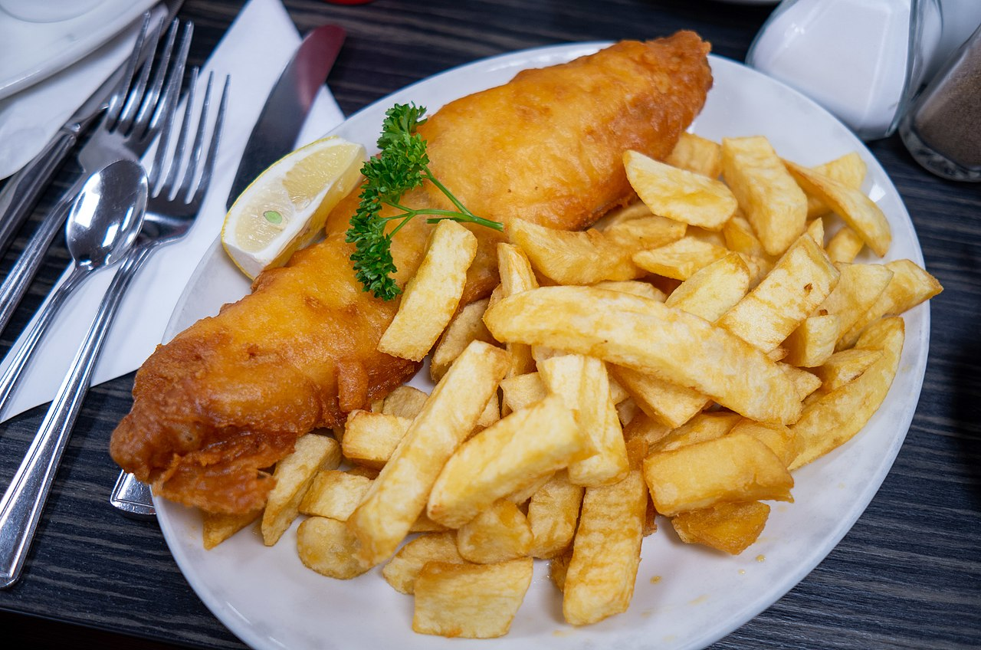

https://en.wikipedia.org/wiki/Fish_and_chips#/media/File:Fish_and_chips_blackpool.jpg

Hotel:

Menu1: Deluxe cereal with fresh fruit and glass of chocolate milk or protein shake

Menu2: Roast chicken or roast lamb sandwiches or kumara chips plus dip

Menu3: Laksa curry with fresh prawns or stuffed eggplant with rice

Pic4:

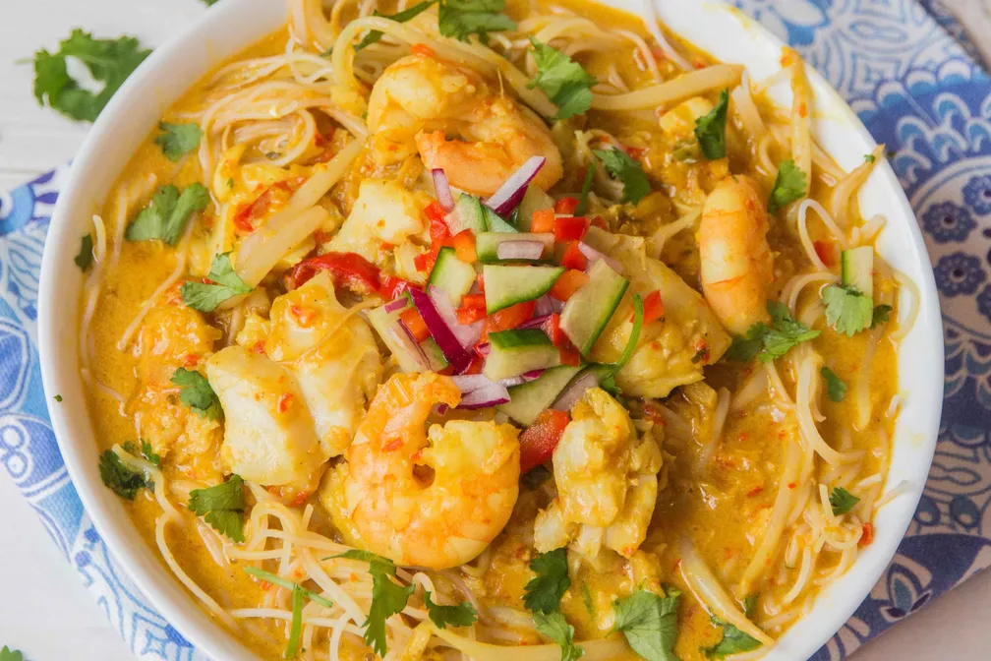

https://food52.com/recipes/30268-seafood-laksa

House:

Menu1: Pancakes with fried banana and bacon or french toast with berry compote

Menu2: Homemade pepperoni pizza or vegetarian platter

Menu3: Lamb cutlets with mint sauce and bread or selected roast vegetables and lentils

Pic4: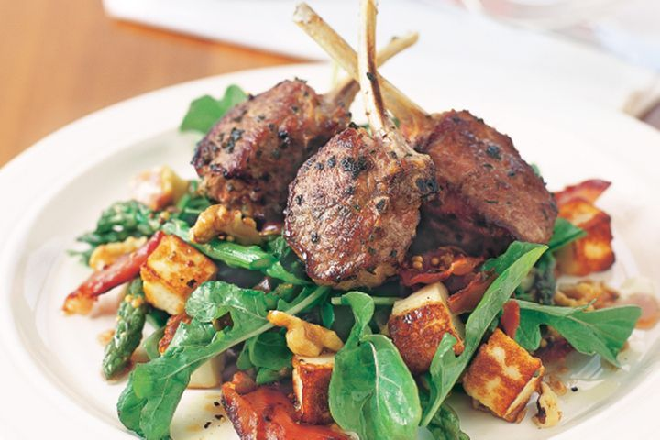

https://www.taste.com.au/recipes/lamb-cutlets-haloumi-walnut-salad/5dc18114-e89b-4061-a686-a6be1ed21dc0